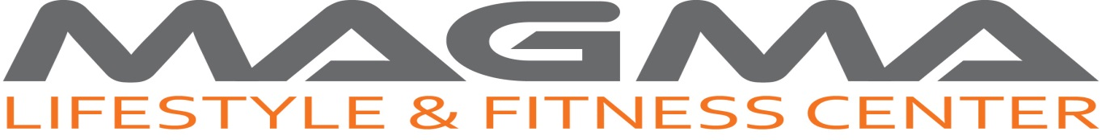
Rules & Regulations

- Opening hours:
6:00 am – 11:00 pm Sundays - Thursdays
8:00 am – 8:00 pm Fridays
8:00 am – 11:00 pm Saturdays

- Discipline:
- Members are required to comply with the instructions given by MAGMA Lifestyle & Fitness Center management & staff on duty. Failing to do so, and in the case of a violation to the present policies, rules or regulations, we reserve the right to prohibit such members from further usage of the facility.
- Members will be held responsible for any damages to the property and/or equipment or injury to any person due to their negligence and/or non adherence to MAGMA Lifestyle & Fitness Center policies, rules and regulations.

- Attire:
All members must be appropriately dressed. Any form of attire which may cause possible infringement to the safety of self or others or potential damage to the equipment, are prohibited. (Proper athletic attire is required sports shirts or tank tops must be worn at all times. N0 ”excessive dress” for weight loss permitted. No jeans or clothing that may “rip” upholstery. Proper non-making athletic shoes are required in fitness center. Protective “closed-toe” shoes must be worn at all times and on all equipment)
The management and staff on duty reserve the right to decide on the suitability of sporting attire worn by members.

- General Conduct:
Members should refrain from talking loudly or indulging in noisy activities that may annoy or distract other users (e.g. dropping weights forcefully) or any other form of conduct that is deemed inappropriate by management or the staff on duty.

- Usage of Equipment:
- All members must observe the instructions and safety precautions to the use of the exercise equipment. If in doubt, members are required to ask a member of staff.
- Members will be held responsible for any damage to the equipment due to wrong or improper use.
- Members are expected to practice good hygiene and gym etiquette by observing the following:
- Returning of all equipment and weights to their proper place after use.
- Wiping down the machines after use
- Allowing others to step in and workout in between their sets
- Limiting cardio workouts to 30 minutes if others are waiting

- Group Fitness Classes:
- For members only.
- A class is subject to cancellation in case participants are less than 5

- Prohibitions:
- Persons under the age of 16 are prohibited from using the facilities unless accompanied by a Personal Trainer.
- Smoking is prohibited on the premises
- No eating is allowed within the entire facility except at the juice bar. Only non-spill bottles or containers shall be allowed onto the exercise area.
- No personal exercise equipment is allowed into the gym. If in doubt, check with the staff on duty. For safety reasons, all mobile phones, mp3 players, etc… should be made inaudible to other users and properly secured to the body of the owner when exercising.

- Usage of Lockers:

For security reasons, members are not allowed to leave their belongings unattended in the facility. Any locker contents left over night -except for yearly rentals- will be removed and disposed of by the end of business the following day. MAGMA Lifestyle & Fitness Center will not be held responsible for damaged or missing items left in day use lockers.

Violation of the above Rules & Regulations and any of Magma Lifestyle & Fitness Center's other relevant policies, rules and regulations will terminate membership privileges immediately. Magma Lifestyle & Fitness Center reserves the right to refuse or dismiss offenders or persons deemed unfit due to health, disease or unsuitable attitude.

I have thoroughly read, understood and accepted the above Rules & Regulations.
Name: ---------------------- Date: ---------------------

